DEPARTMENT OF COMPUTER SCIENCE



SQE LAB ASSIGNMENT NO 4

NAME | REGISTRATION NO
MAHREEN MALIK | FA23-BSE-006
MAYAM AHMED | FA23-BSE-008
EIMAN HASSAN | FA23-BSE-016

COURSE | SQE
SUBMITTED TO | MAM MUNNAZZA MUSHTAQ
DATED | 18-MAY-2026

COMSATS UNIVERSITY ATTOCK CAMPUS

Lab Assignment 4
Project: Expense tracker
Project overview:
This project is a Python-based Expense Tracker System developed to help users efficiently manage and monitor their daily expenses. It allows users to add, view, update, delete, and search expense records while maintaining a simple and user-friendly structure. The system is built using core Python concepts such as functions, loops, and conditional statements, ensuring strong programming logic and ease of execution. In addition to development, the project also focuses on software quality practices, including manual testing with test cases, automated testing using the unittest framework, bug reporting, and code quality analysis using SonarQube. Furthermore, security analysis is performed using Snyk to identify vulnerabilities in dependencies. Overall, this project demonstrates the complete software development lifecycle, from implementation to testing, quality assurance, and version control using GitHub.
Core Functionalities:
- Add Expense – records category, amount, and date
- View Expenses – lists all stored expenses
- Calculate Total – sums all expense amounts
- Category Summary – groups expenses by category
- Delete Expense – removes a record by index
Expense_tracker.py:
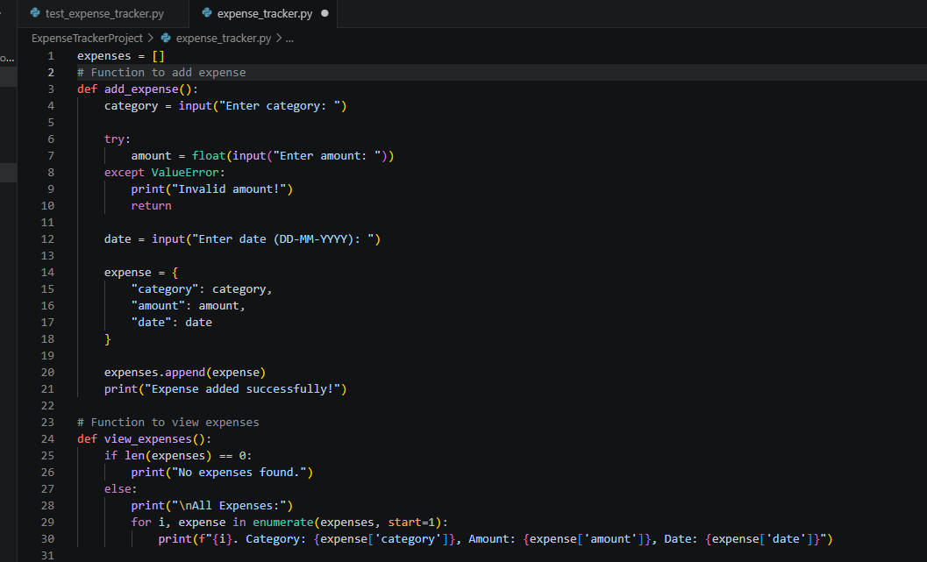
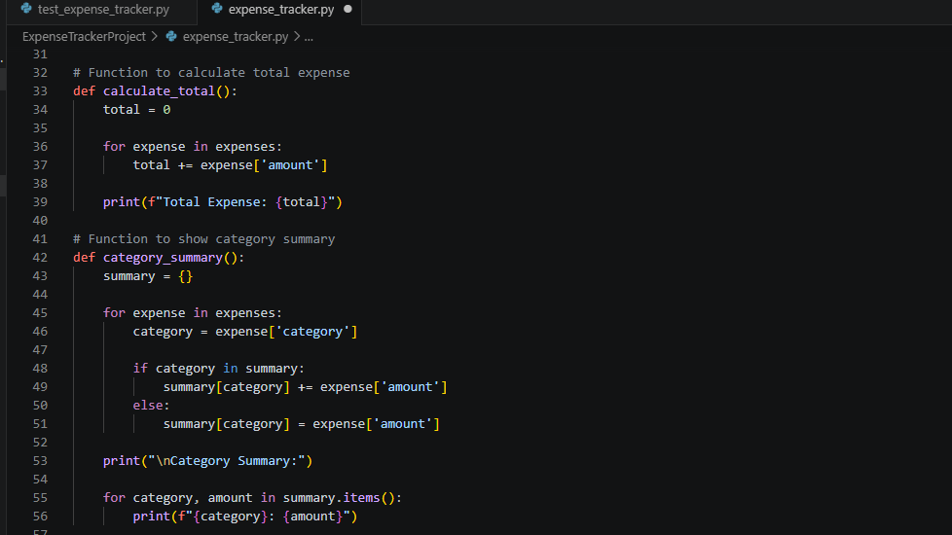
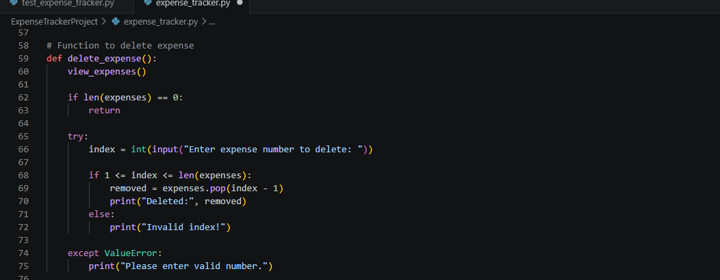
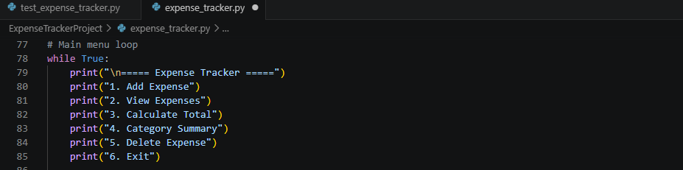
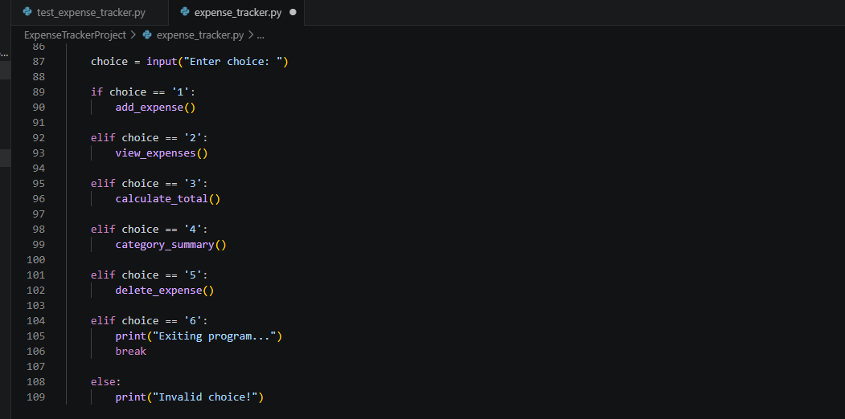
Add expenses:
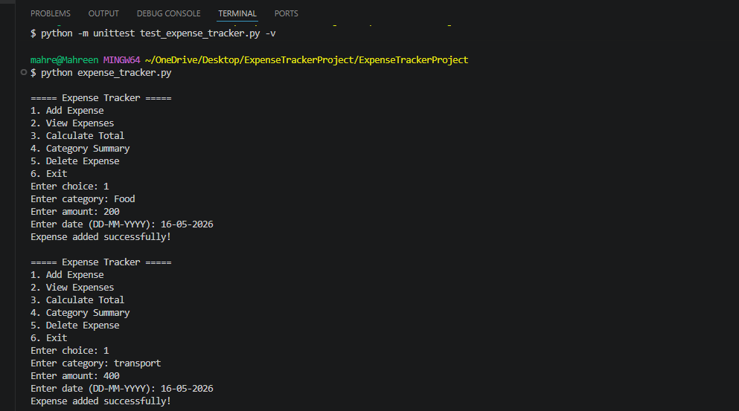
View expenses:
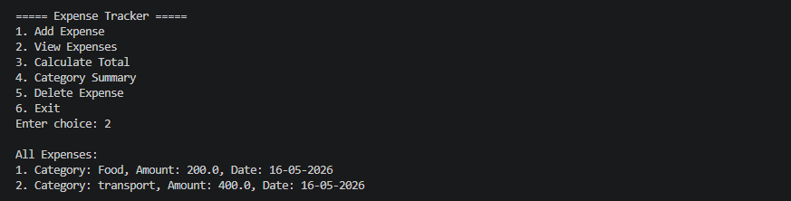

Calculate total:
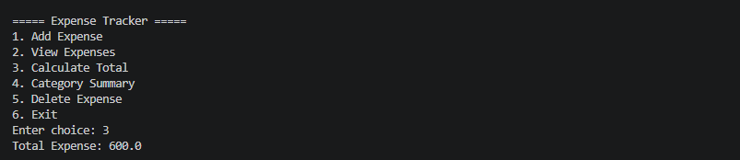
Category summary:
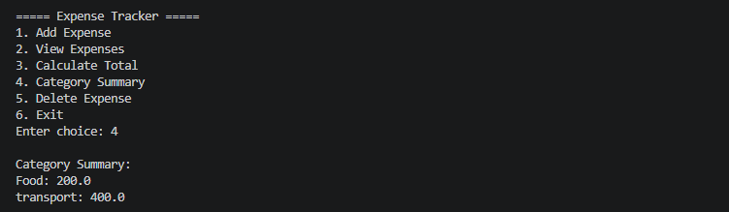
Delete expense:
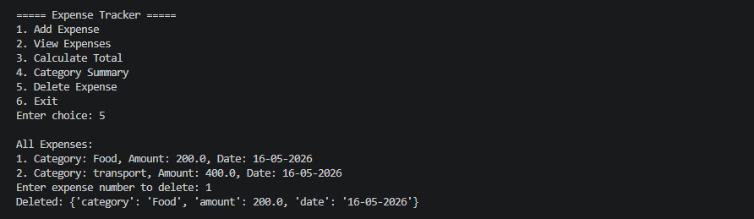
Exit:
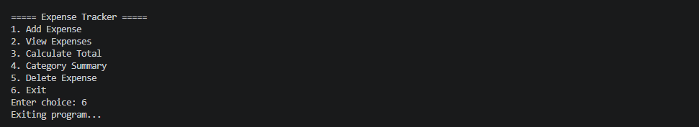

Manual testing:
Unit Test Implementation – test_expense_tracker.py
All 18 test cases above were implemented in Python using the unittest framework. The test file is organised into four test classes:
- TestAddExpense (TC-01 to TC-05)
- TestViewExpenses (TC-06, TC-07)
- TestCalculateTotal (TC-08 to TC-10)
- TestCategorySummary (TC-11 to TC-13)
- TestDeleteExpense (TC-14 to TC-18)
Test_expense_tracker.py:
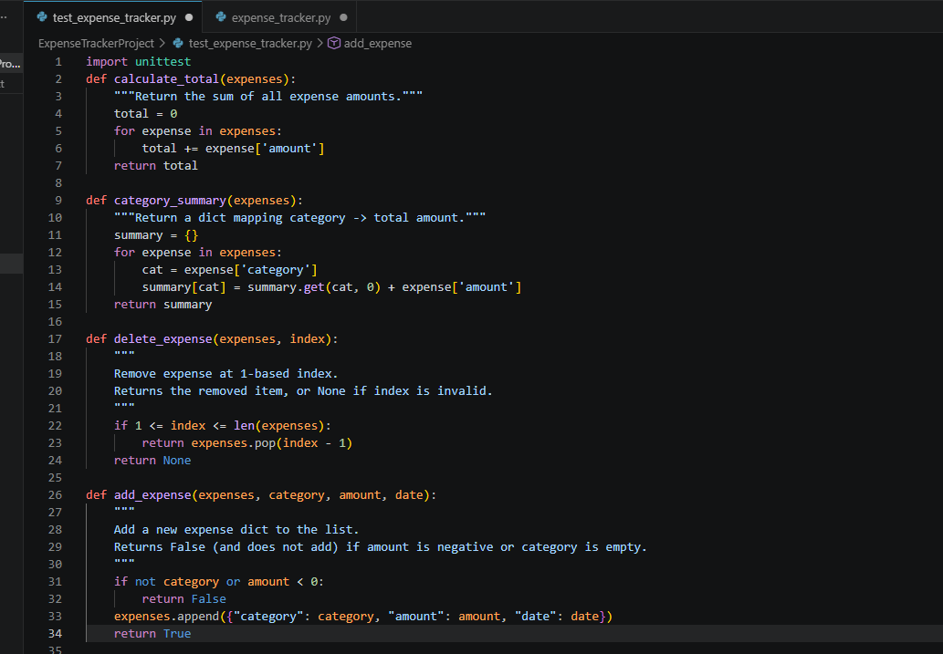
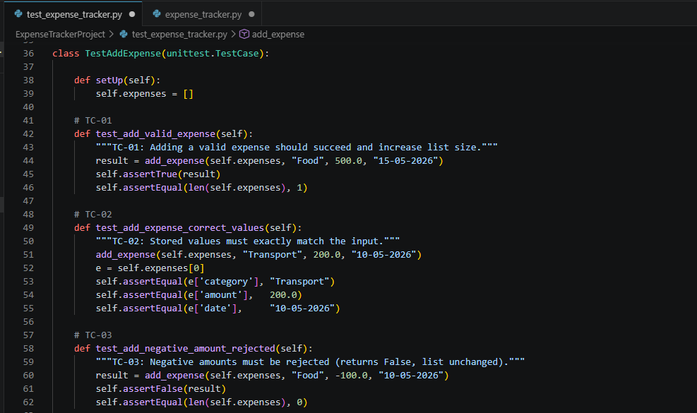
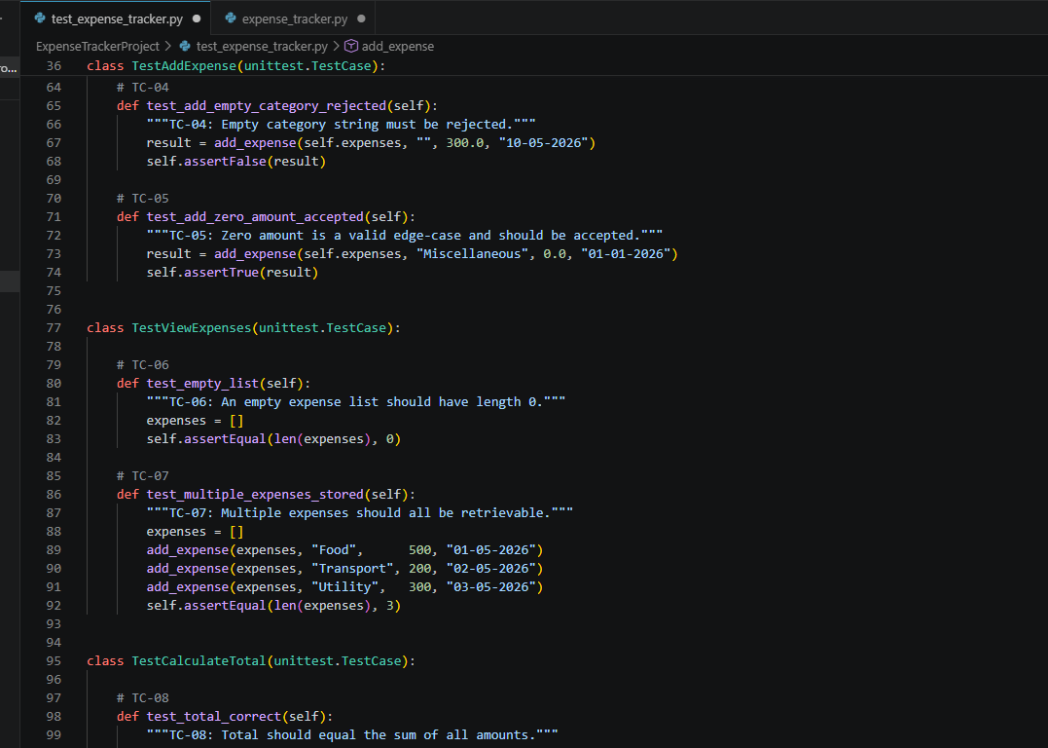
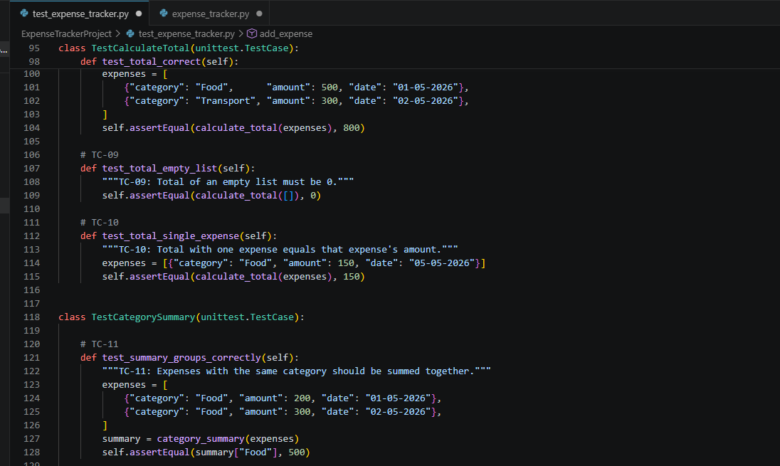
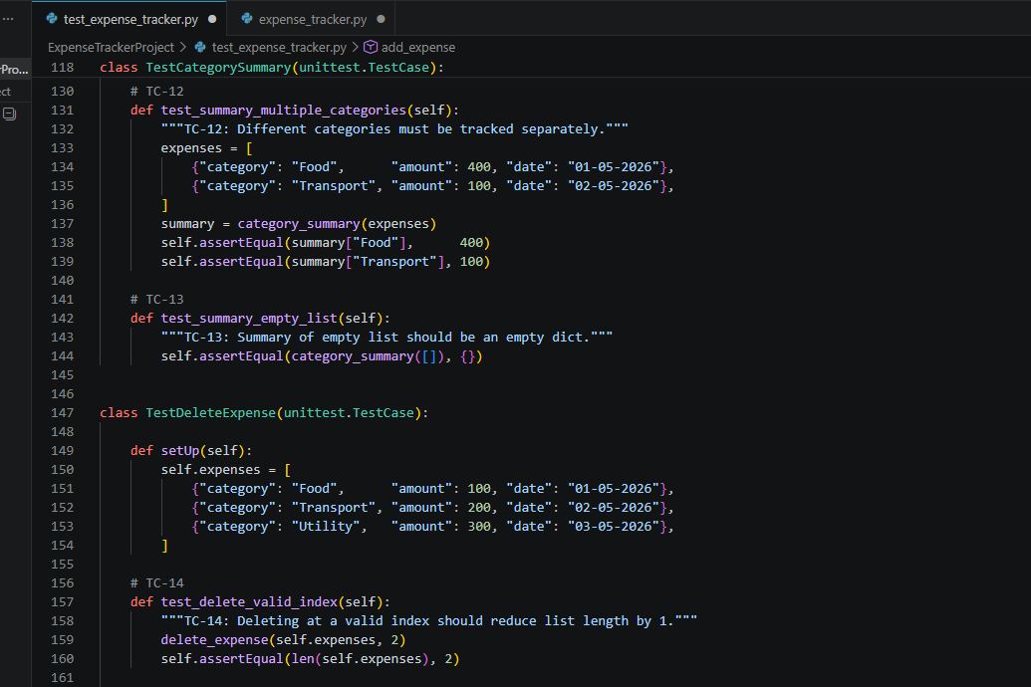
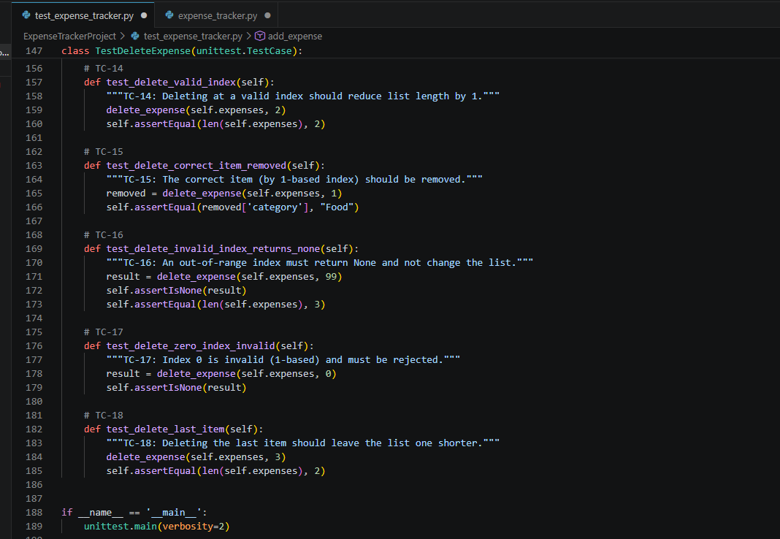
Run testing:
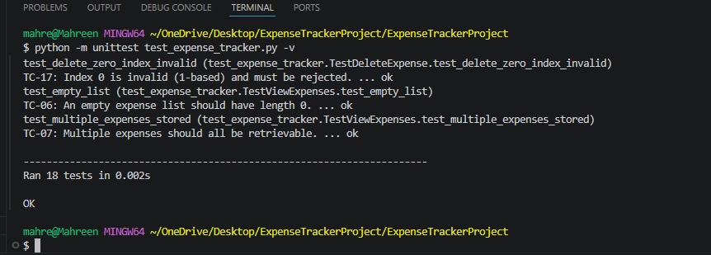
Bug Report:
BG-01
- Bug ID: BG-01
- Bug Name: Negative Amount Accepted
- Description: In add_expense(), there is no validation for negative amount. A user can enter -500 and it gets stored without any error.
- Expected Result: System should reject negative amounts and show: "Amount cannot be negative. Please enter a valid amount."
- Actual Output: Negative amount like -500 is accepted and stored. Total calculation then returns a wrong value.
- Severity: High
- Status: Open
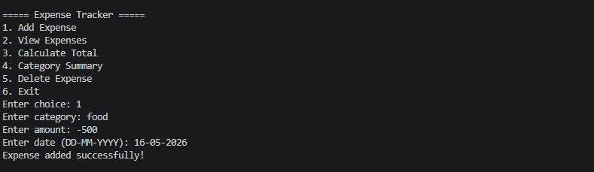
BG-02
- Bug ID: BG-02
- Bug Name: Empty Category Accepted
- Description: In add_expense(), there is no check for empty category. If user presses Enter without typing anything, a blank category is stored.
- Expected Result: System should reject empty category and show: "Category cannot be empty."
- Actual Output: Blank category is accepted and stored. Summary shows an entry with an empty key.
- Severity: Medium
- Status: Open
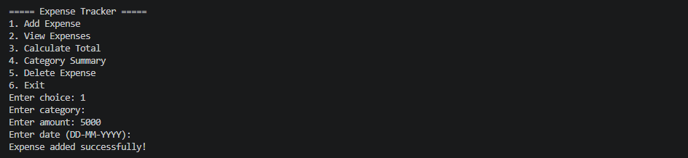
BG-03
- Bug ID: BG-03
- Bug Name: Invalid Date Format Accepted
- Description: In add_expense(), the date is stored as a plain string with no format check. Any text like "abc" or "99-99-9999" is accepted.
- Expected Result: System should only accept dates in DD-MM-YYYY format and reject anything else with: "Invalid date format. Please use DD-MM-YYYY."
- Actual Output: Invalid strings like "abc" are accepted and stored without any error.
- Severity: Medium
- Status: Open
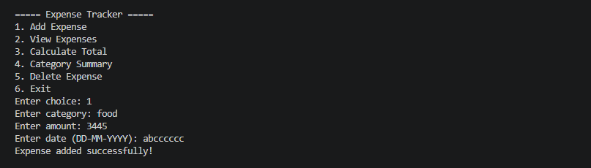
BG-04
- Bug ID: BG-04
- Bug Name: Data Not Saved to File
- Description: The expenses list exists only in memory. Although expenses.txt is present in the folder, it is never read on startup or written to on exit.
- Expected Result: Expenses should be saved to expenses.txt on every change and loaded back on startup so data persists between sessions.
- Actual Output: All expense data is lost every time the program is closed. The expenses.txt file remains empty and unused.
- Severity: High
- Status: Open

BG-05
- Bug ID: BG-05
- Bug Name: Case-Sensitive Category Names
- Description: In category_summary(), categories are compared with case sensitivity. "Food" and "food" are treated as two different categories.
- Expected Result: "Food", "food", and "FOOD" should all be grouped under the same category in the summary.
- Actual Output: "Food" and "food" appear as two separate categories with amounts listed separately instead of being combined.
- Severity: Low
- Status: Open
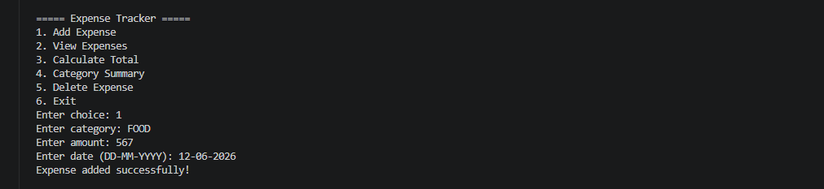
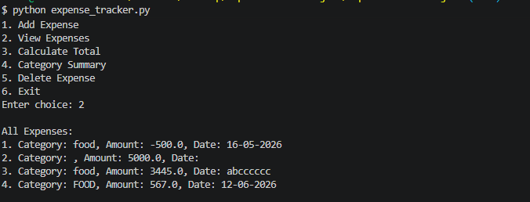
Code analysis:
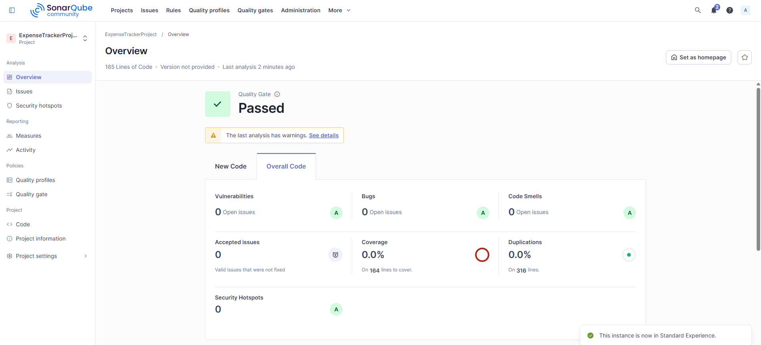
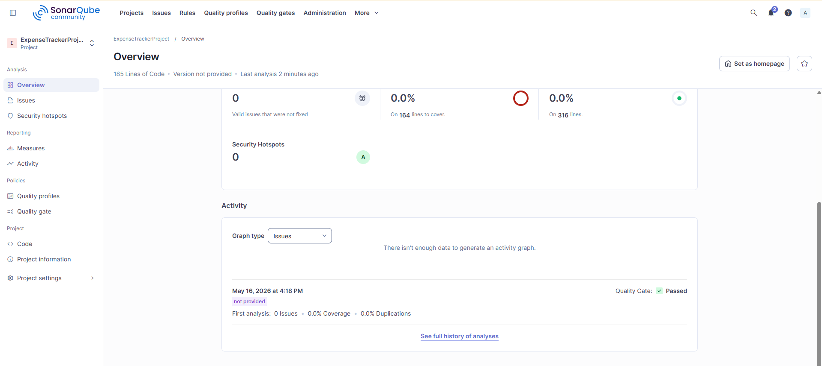
Maintainability:
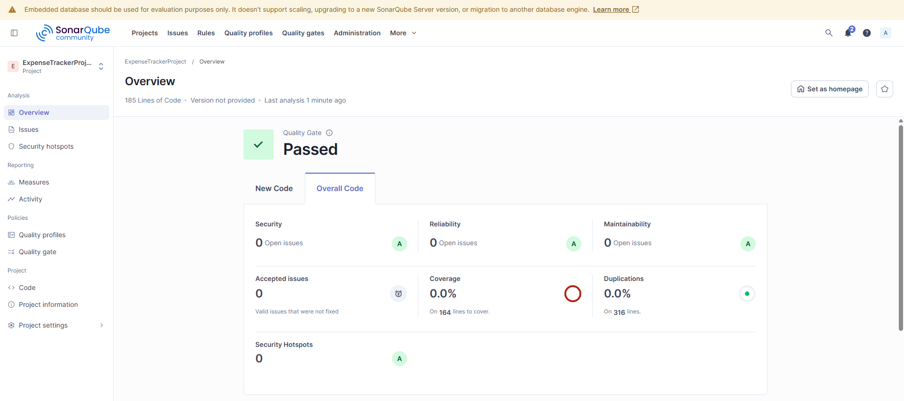
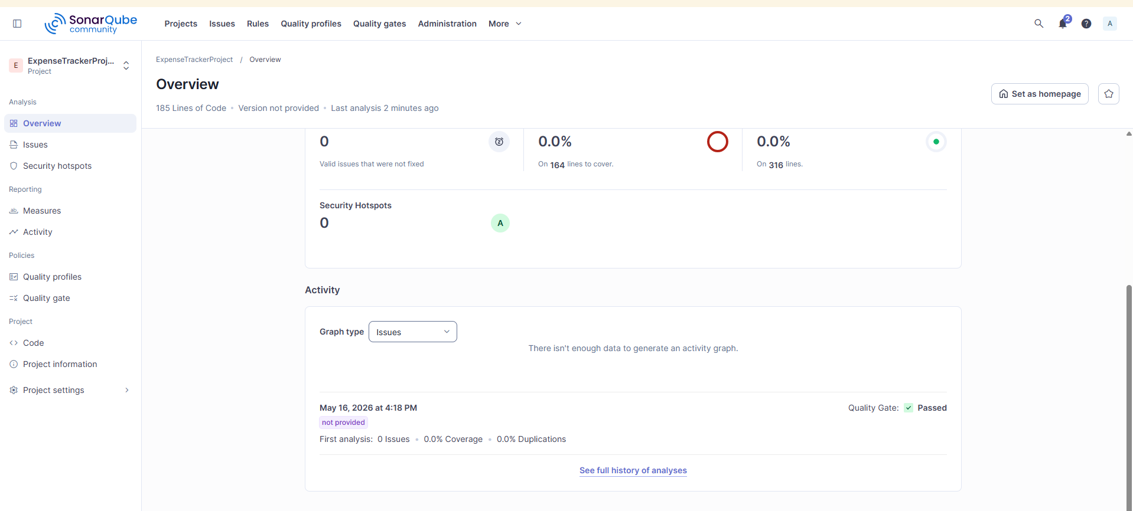

Git push:
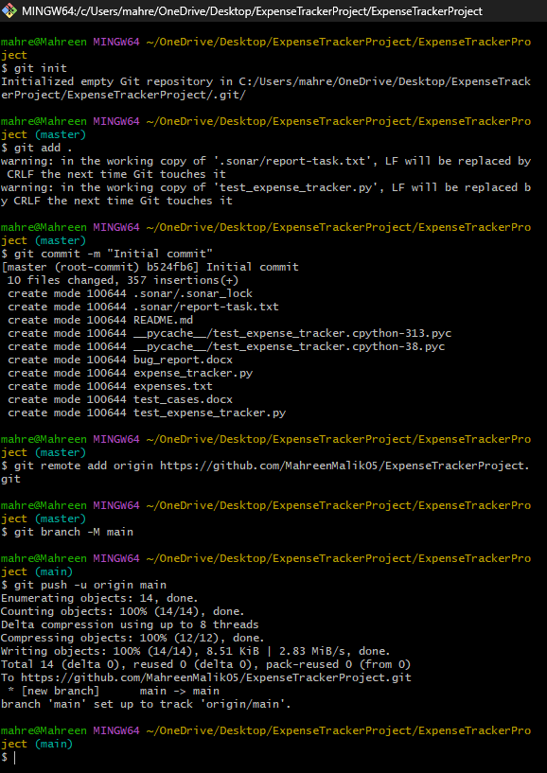
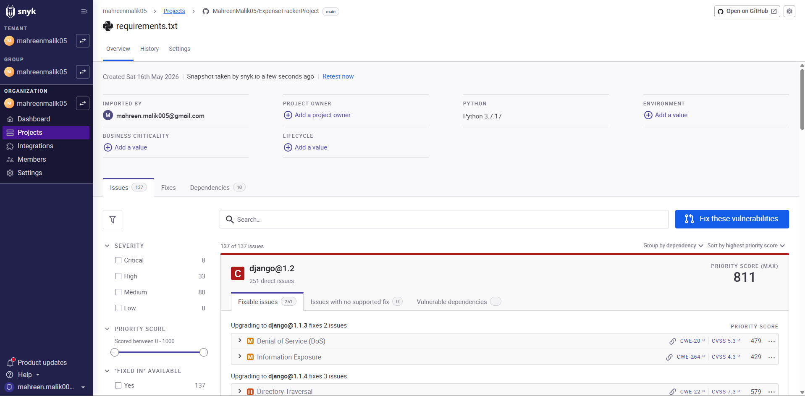
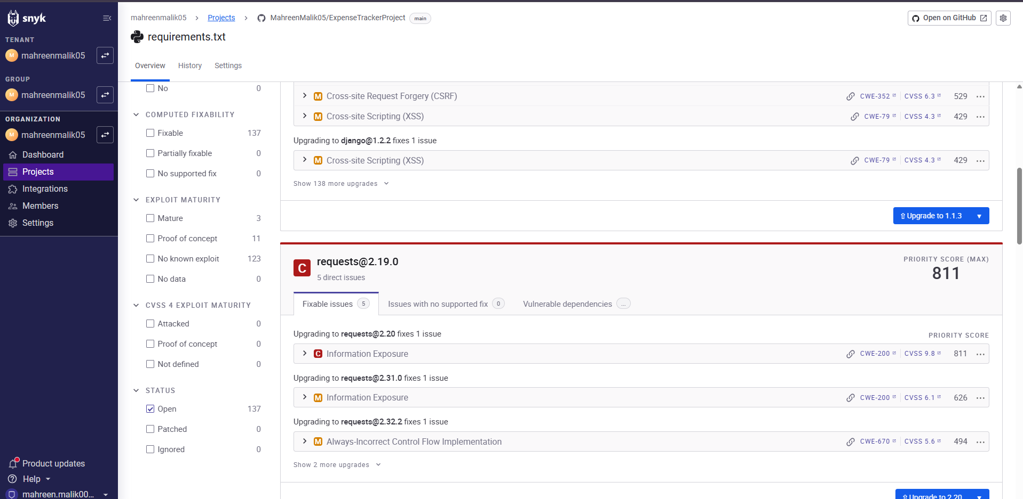
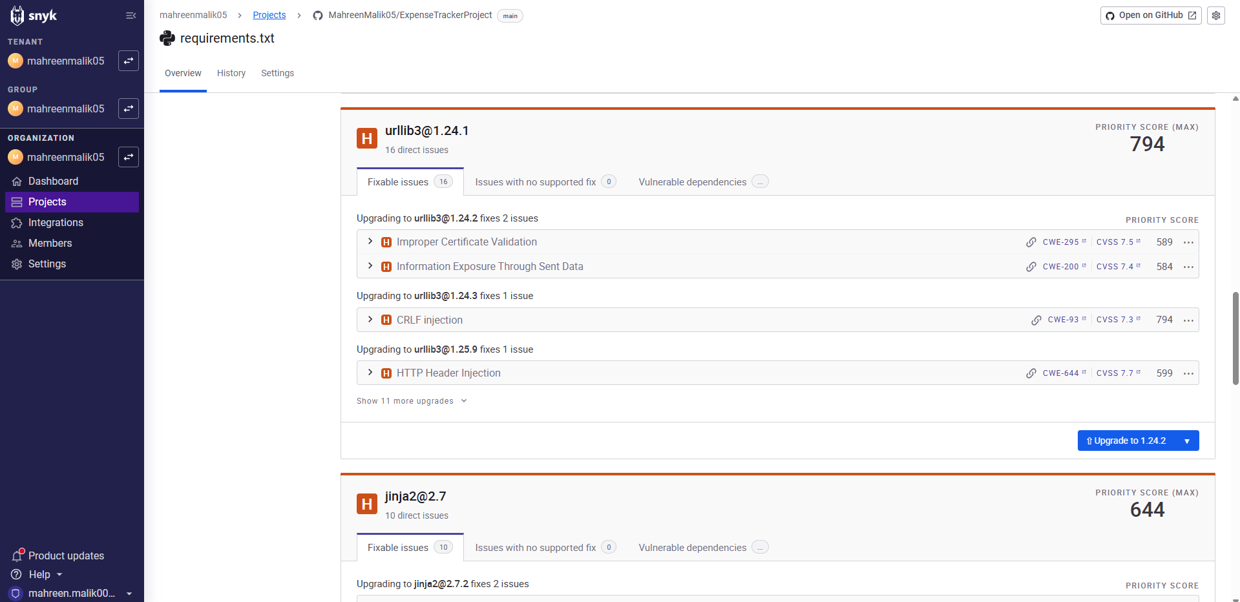
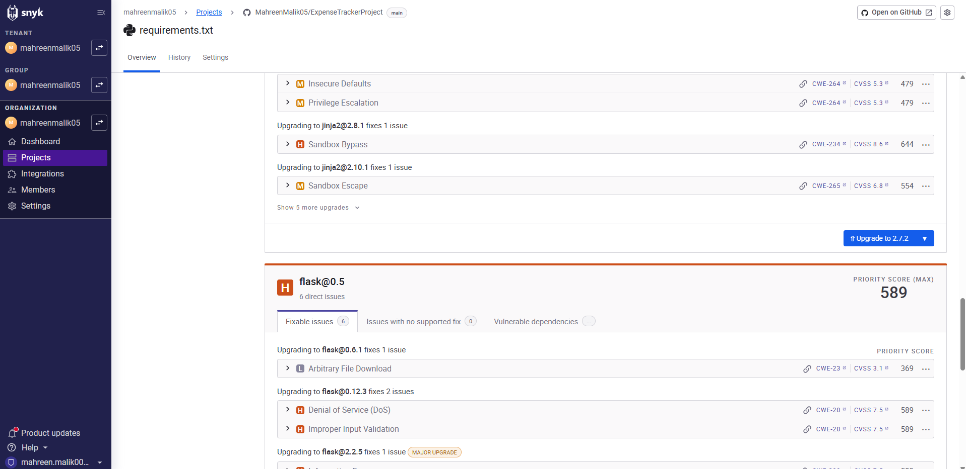
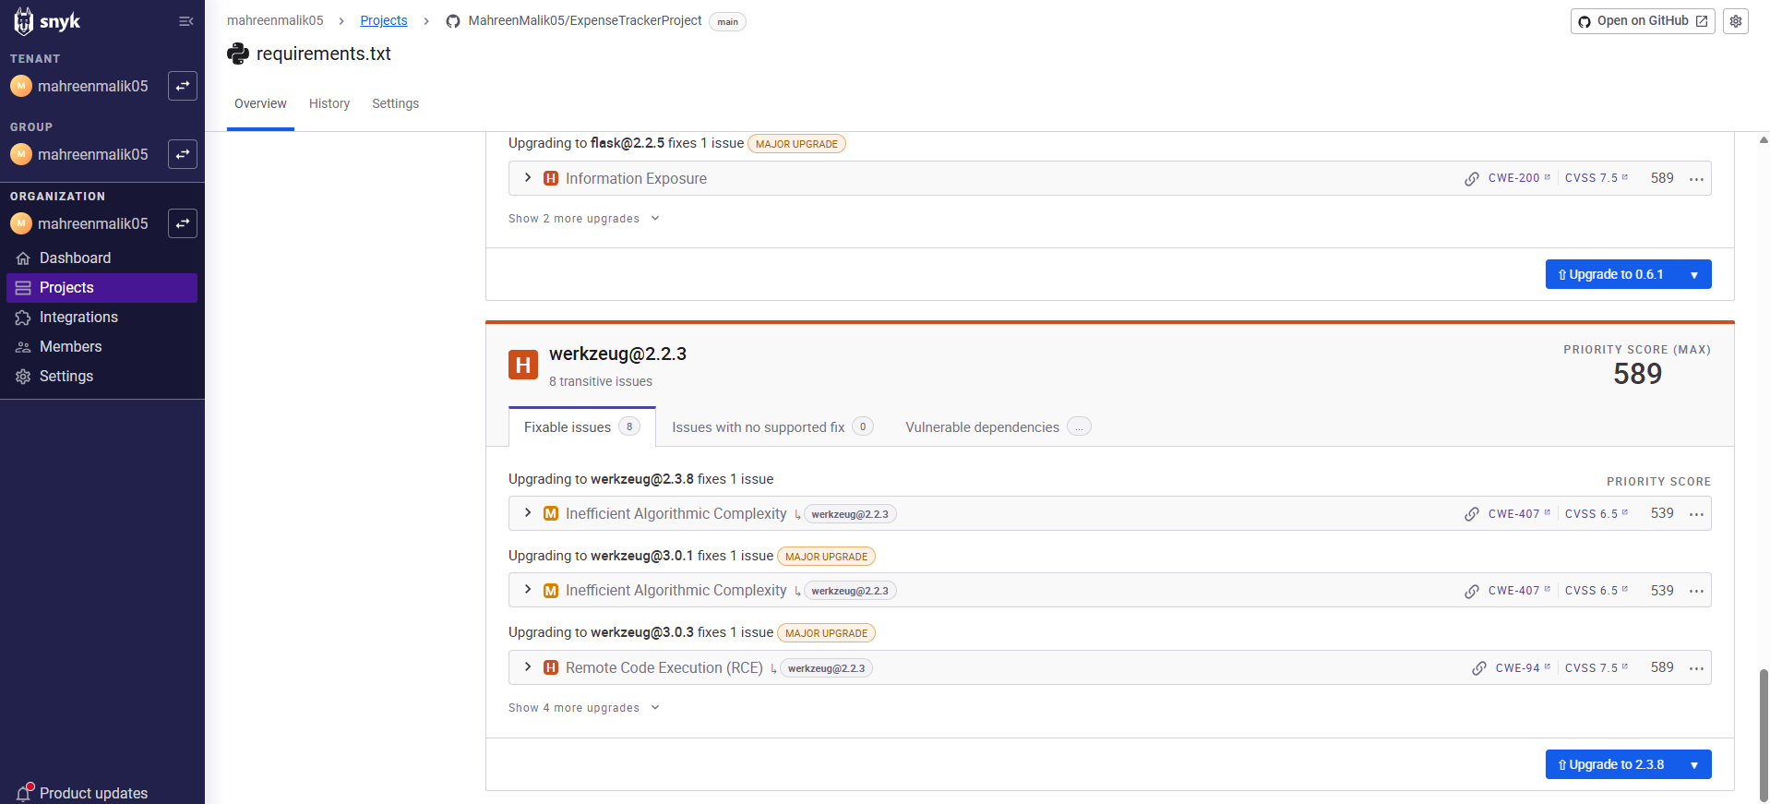
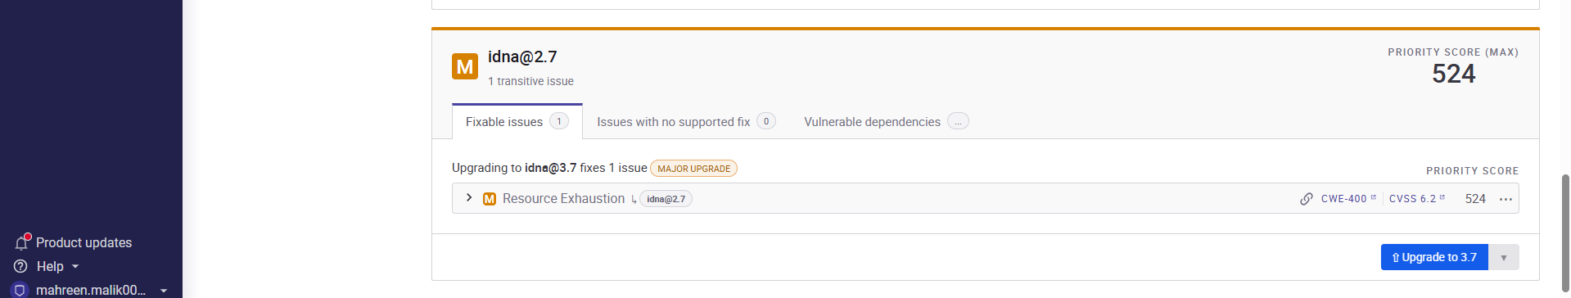
Github repo link:
https://github.com/MahreenMalik05/ExpenseTrackerProject.git

